Users manual (a draft).

Installation

To use the stand-alone version of PlaNet, you need to have following items:

**-Python v.2.7 :**

<http://www.python.org/download/>

For windows, it is higly recommended that you use the 64-bit version: [Python 2.7.1 Windows X86-64 installer](http://www.python.org/ftp/python/2.7.1/python-2.7.1.amd64.msi), on a machine with >4GB of RAM.

**-Numpy, Scipy and MatPlotLib.**

For Windows, the three modules are available from:

-[numpy-1.5.1.win-amd64-py2.7.‌exe](javascript:;)

-[scipy-0.8.0.win-amd64-py2.7.‌exe](javascript:;)

-[matplotlib-1.0.1.win-amd64-py2.7.‌exe](javascript:;)

For other platforms, please use:

-Numpy: <http://sourceforge.net/projects/numpy/files/NumPy/1.5.1/>

-SciPy: <http://sourceforge.net/projects/scipy/files/scipy/0.9.0b1/>

-MatPlotLib: <http://sourceforge.net/projects/matplotlib/files/matplotlib/matplotlib-1.0.1/>

Please make sure to use the 64-bit versions, corresponding to v2.7 of your python

**-GraphViz:**

Download Graphviz from: <http://www.graphviz.org/Download.php>

For windows, download the program and install it in folder: C:/Graphviz, so the path to neato.exe is: C:/Graphviz/bin/neato

For other platforms, enter the path to neato in the first line in files: ancestralNetwork.py, networkComparer.py, networkViewer.py.

Usage

Two executable programs exist in PlaNet folder:

**- HRRnetworkCreator.py**

With this program you can use your own expression data to create networks readable by PlaNet.

The file you input into the program should be formatted as shown on figure below (Fig. 1). The spaces between columns represent tab-spaces.

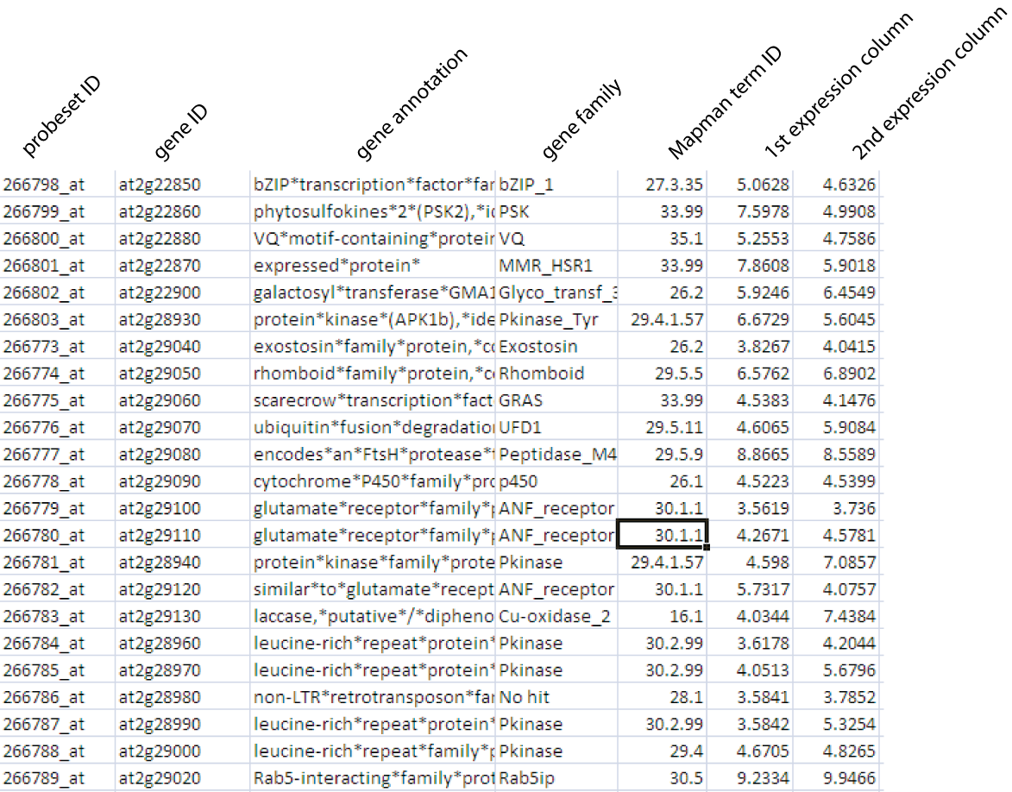

Fig 1.

The first column of the file must contain a unique probeset ID, the second column contains gene ID (can be same as probeset ID if unknown), the third column contains description of the gene, the fourth column contains the name of PFAM family the probeset is associated to (replace family name with No hit, if unknown), the fifth column represents Mapman term id (replace with 35.2 if unknown). Expression values start from sixth column.

The network construction takes two steps:

1. Load expression matrix and calculate ranks. This step might take several minutes or hours, depending on the size of the dataset. “.Ranks” file type is created
2. Calculate HRR values. This step transforms the ranks into HRR based network. “.HRR” file type is created.

**-PlaNet.py**

This program gives you most of the functionality of web-based planet.

-Start the program.

-Select the organims you want to analyze by navigating to “Change organism/database” and selecting the network of interest. Click open.

-Select the gene of interest by navigating to “Start/Select genes for analysis”. In here you can specify probeset ID, gene ID, or keyword (which must be present in annotation of the gene). Click find.

**Following analyses are now awailable:**

**-Display probeset specific report.**

You need to select the probeset of interest, specify the HRR-value cutoff (default 30) and step-size (default 2). Click CALCULATE! The program generates “result.html” which can be viewed in a browser. The file contains:

-Expression profile of the probeset across tissues present in tissue atlas

-HRR based co-expression network generated using the parameters specified

-Mapman ontology analysis of the network

-Pearson correlation co-efficient list where probeset of interest has been used as query

**-NetworkComparer pipeline:**

The implementation of the pipeline is identical to the one used on PlaNet homepage. The analysis takes two steps:

-**NetworkComparer Step I: Find similar co-expression networks:** In this step you need to specify the probeset you want to analyze, together with HRR cut-off and step size. In addition, you can also specify what organisms/networks you want to include in the comparison. Click “Calculate” to initiate the analysis. The program generates the file “NetComp.html”. Analyze the file and proceed with step 2.

-**NetworkComparer Step II: Extract ancestral network:** Select the probesets you want to compare and click on “Calculate”. The program generates “ancNet.html” which is identical to to the last step of NetworkComparer analysis on PlaNet homepage.